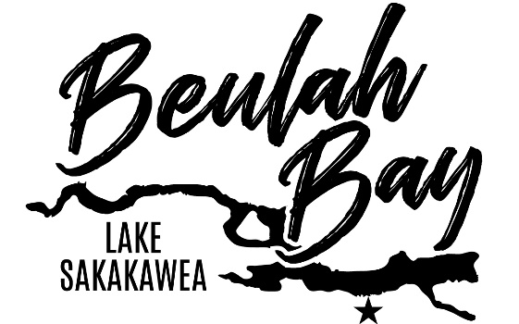
$20.00 Per Person
All proceeds go towards improvements at Beulah Bay.

Beulah Bay Campground’s
Annual Dakota Walleye Classic Family 5K Run/Walk
Race starts at the boat docks at Beulah Bay
Saturday July 25th – Registration starts at 9:00
Race starts at 9:30 am
To guarantee a shirt registration forms must be handed in by July 10th

Name: _________________________________________
Address: ______________________________________
City/State/Zip: ________________________________
Phone: _____________________________________
Shirt Size (circle one): YS YM YL AS AM AL AXL AXXL
IN CONSIDERATION OF YOUR ACCEPTING THIS ENTRY, I hereby, for myself, my heirs, and administrations, waive and release any and all rights and claims, for damages I may have against Energy Wellness Center and co-sponsor, their agent, representatives, successors, and assigners for any and all injuries by me at this event. For competitors under the age of 18. I, the undersigned parents or legal guardian of the competitor, herby approve and confirm the waiver and release.
Sign: __________________________________________ Date: ___________________________________
Registration sheets can be handed in or mailed to: Beulah Park District/Sonja Dutchuk
1900 Central Ave North
Beulah, ND 58523

