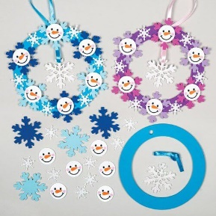
January Kids and Craft
Winter Wreath
Dates
Monday January 27th @10:00 am
Monday January 27th @ 6:00 pm
Cost: $5.00
All supplies will be provided
Tuesday January 28th @ 2:00 pm

Name: _________________________
Age: ___________________________
Check: _________________ Cash: _________
DATE: January 27th 10:00 am
January 27th 6:00 pm
January 28th 2:00 pm
Statement of Release: I agree to release the City of Beulah, The Beulah Parks and Recreation, and all their employees of all liability related to accidents or injuries which myself or a member of my family might incur while participating in the above stated activity. I also give permissions for emergency medical procedures to be administrated if I cannot be contacted in the event of emergency.
Signature of Parent/Guardian: _________________________________ Date: ______________

